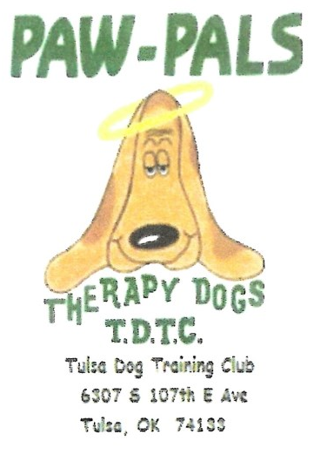

Paw Pals Code of Ethics

- Serving as a Tulsa Dog Training Club Paw Pals volunteer is a privilege, which comes with responsibilities. While visiting an approve facility, you must adhere to the highest ethical standards.
- While acting on behalf of Paw Plas, you will act in a manner commanding respect for yourself, Tulsa Dog Training Club, the facility you are visiting, and its staff. If you observe a fellow Paw Plas member violating Code of Ethics, you must report it to the TDTC Paw Pals Coordinator.
- You will respect patient/resident/client/student information as being confidential. If a patient/resident/client/student confides in you, what is said is to be held in confidence. If, however, the patient/resident/student confides that they are considering harming themselves or are being physically or sexually abused, you MUST immediately report what was said to the appropriate authorities. Under no circumstances will you take photos or videos of a patient/resident/client/student and their surroundings without proper permission.
- You are to be tactful when speaking. The time for tact begins before you speak, not after. You must avoid political or religious topics. Do not ask for personal information, such as “What happened to you? What is wrong with you? How did that happen? etc.”
- Never Offer advice to a patient/resident/client/student or their family regarding the person’s illness or circumstance, nor should you share your personal experiences with an illness or other similar circumstance.
- Do not use your association with the facility to seek free medical advice or to seek other favors.
- If you observe conduct that appears to be contrary to the facility policies, questions should be direct3d to the facility’s contact person and not to the patient/resident/client/student.
I have read, understand, and agree to follow the Paw Pals Code of Ethics.

Name Date

